

Semester Two

Examination 2017

Question/Answer booklet

MATHEMATICS
SPECIALIST UNITS 3 & 4

Section One:
Calculator-free

Student Name: _____________________________________
Teacher’s Name: _____________________________________

Time allowed for this section
Reading time before commencing work: five minutes
Working time for paper: fifty minutes

Material required/recommended for this section

To be provided by the supervisor
This Question/Answer booklet
Formula Sheet

To be provided by the candidate
Standard items: pens (blue/black preferred), pencils (including coloured), sharpener, correction tape/fluid, erasers, ruler, highlighters

Special Items: nil

Important note to candidates
No other items may be taken into the examination room. It is your responsibility to ensure that you do not have any unauthorised notes or other items of a non-personal nature in the examination room. If you have any unauthorised material with you, hand it to the supervisor before reading any further.

Structure of this paper

 | Number of questions available | Number of questions to be attempted | Working time (minutes) | Marks available | Percentage of exam
Section One  Calculator—free | 8 | 8 | 50 | 50 | 35
Section Two  Calculator—assumed | 14 | 14 | 100 | 100 | 65
 |  |  |  |  | 100

Instructions to candidates

- The rules for the conduct of Western Australian external examinations are detailed in the
Year 12 Information Handbook 2017. Sitting this examination implies that you agree to abide by these rules.

- Answer the questions according to the following instructions.

Show all your working clearly. Your working should be in sufficient detail to allow your
answers to be checked readily and for marks to be awarded for reasoning. Incorrect answers given without supporting reasoning cannot be allocated any marks. For any question or part question worth more than two marks, valid working or justification is required to receive full marks. If you repeat an answer to any question, ensure that you cancel the answer you do not wish to have marked.

It is recommended that you do not use pencil, except in diagrams.

- You must be careful to confine your responses to the specific questions asked and to follow any instructions that are specific to a particular question.

- Spare pages are included at the end of this booklet. They can be used for planning your responses and/or as additional space if required to continue an answer.
- Planning: If you use the spare pages for planning, indicate this clearly at the top of the page.
- Continuing an answer: If you need to use the space to continue an answer, indicate in the original answer space where the answer is continued, i.e. give the page number. Fill in the number of the question that you are continuing to answer at the top of the page.

- The Formula Sheet is not handed in with your Question/Answer Booklet.

Section One: Calculator–free 35% (50 marks)

This section has eight (8) questions. Attempt all questions. Write your answers in the spaces provided.
Spare pages are included at the end of this booklet. They can be used for planning your responses and/or as additional space if required to continue an answer.

Working time: 50 minutes

Question 1 (6 marks)

Give exact expressions for each of the following in the form a + bi.

(a) 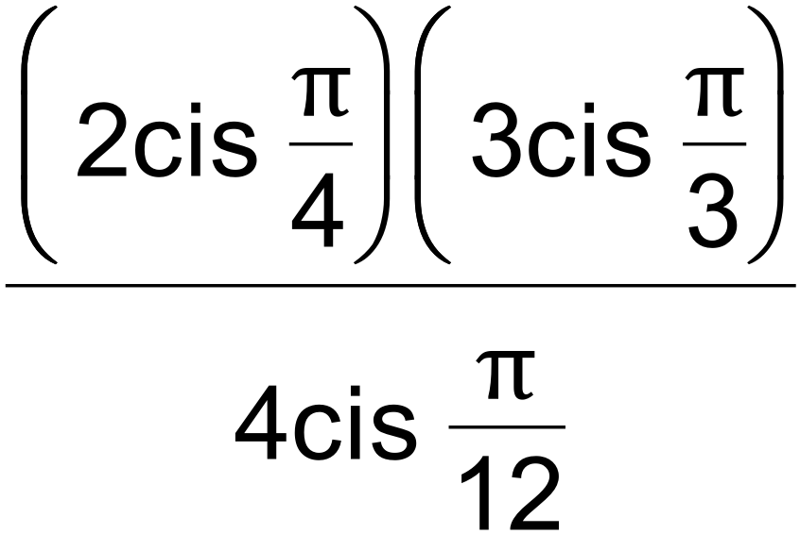 (1 mark)

(b) 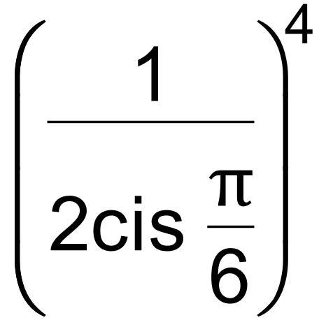 (2 marks)

(c) 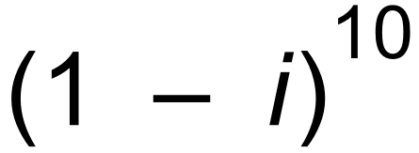 (3 marks)

Question 2 (4 marks)

Consider 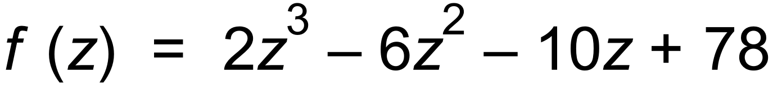.

Solve 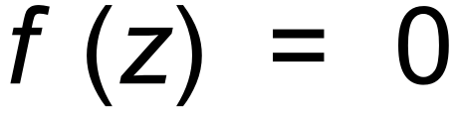, if we know that f (−3) = 0. (4 marks)

Question 3 (4 marks)

Consider the complex equation 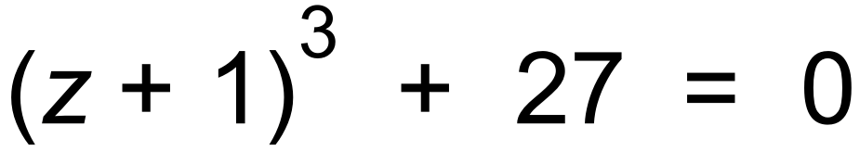.

Solve the equation, using De Moivre’s Theorem, leaving your answers in polar format. (4 marks)

Question 4 (6 marks)

(a) Express 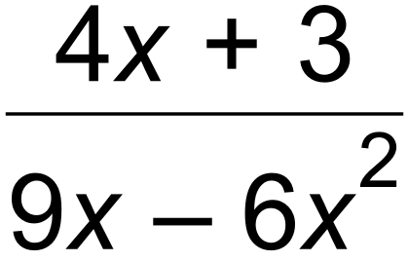 in the format 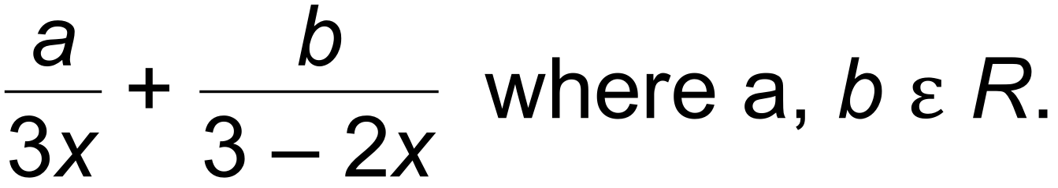 (3 marks)

(b) Hence, determine 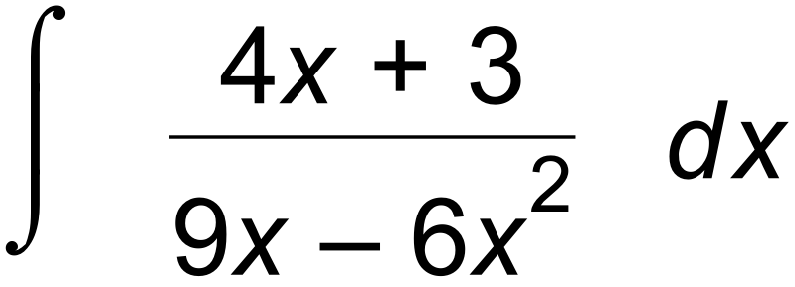. (3 marks)

Question 5 (8 marks)

Evaluate each of the following integrals.

(a) 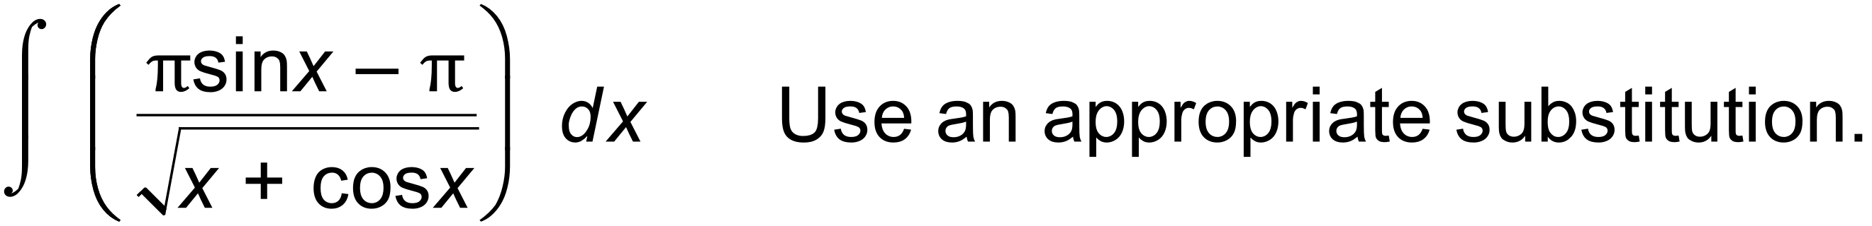 (4 marks)

(b) 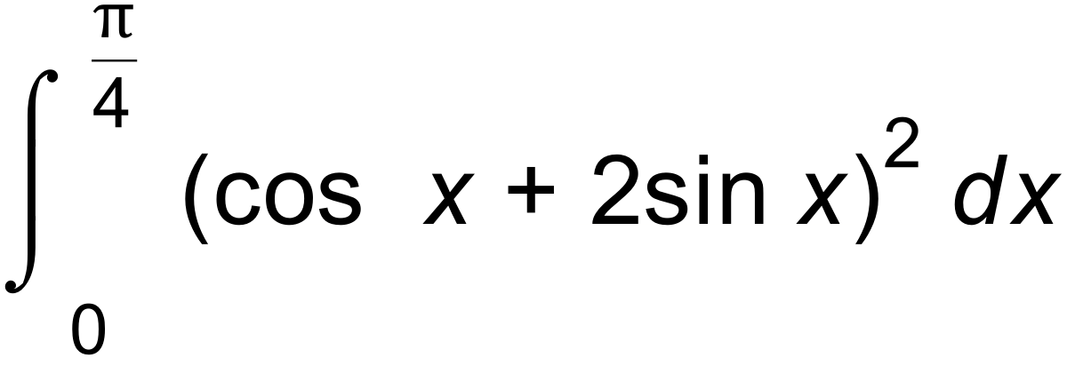 (4 marks)

Question 6 (8 marks)

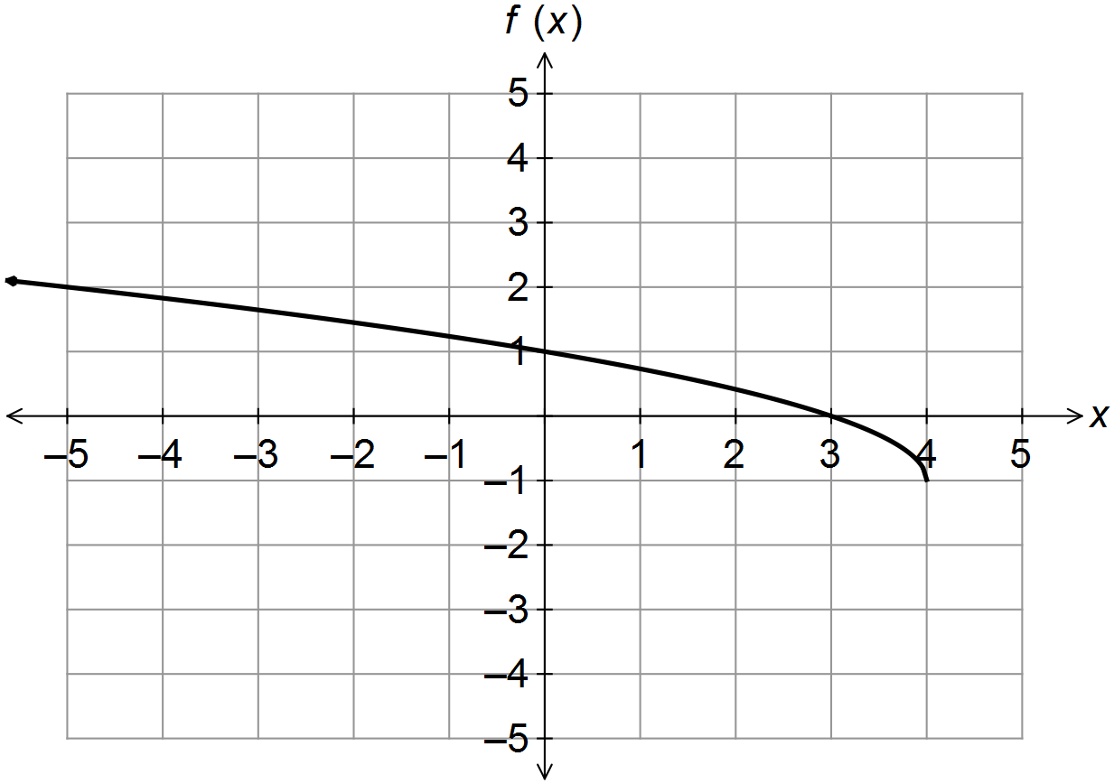(a) The graph of

(i) Sketch the graph of 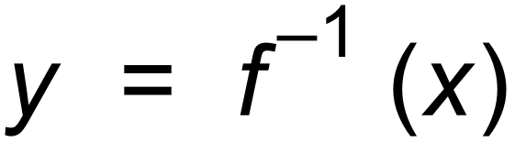 on the coordinate axes below. (1 mark)
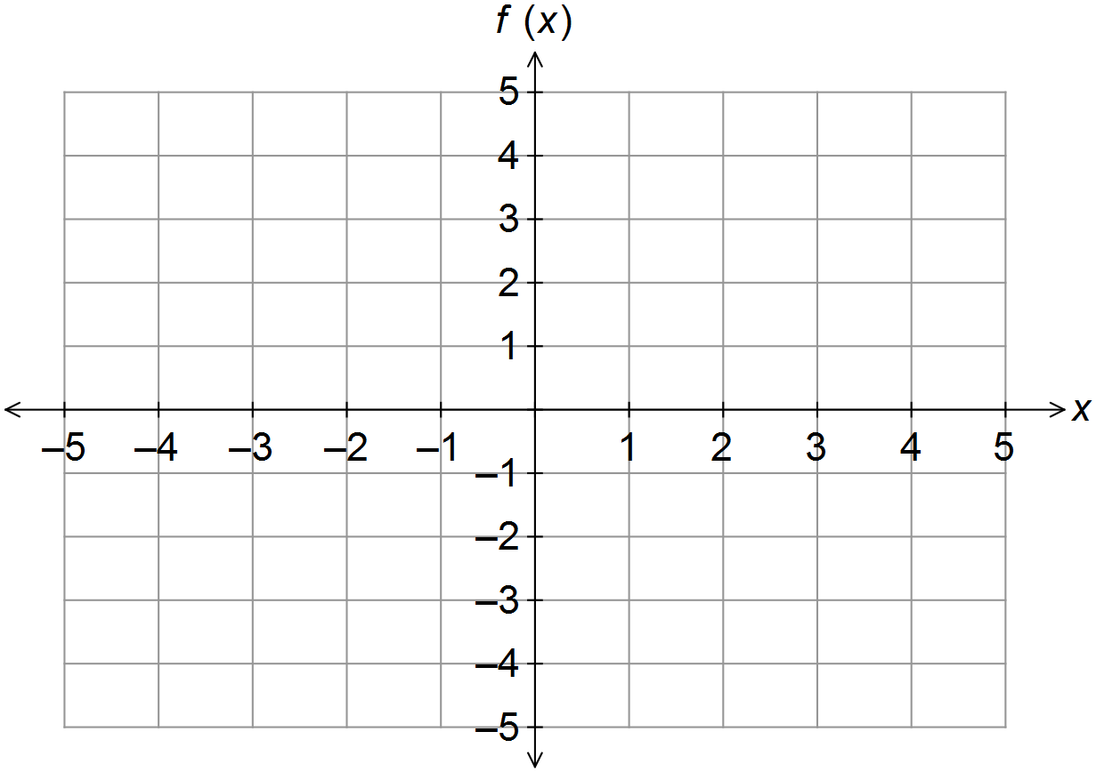

(ii) Sketch 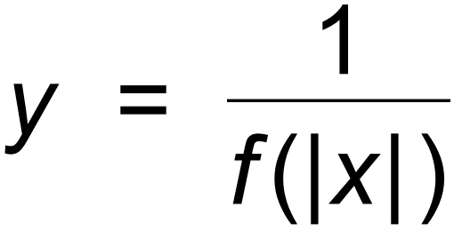 on the axes below. (4 marks)



(b) Given that g (x) = 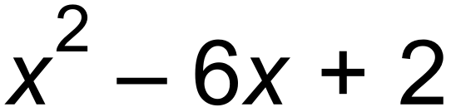, find 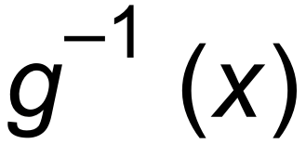, by restricting the domain of g (x) to its
largest allowable domain. (3 marks)

Question 7 (6 marks)

Points A, B and C have respective position vectors 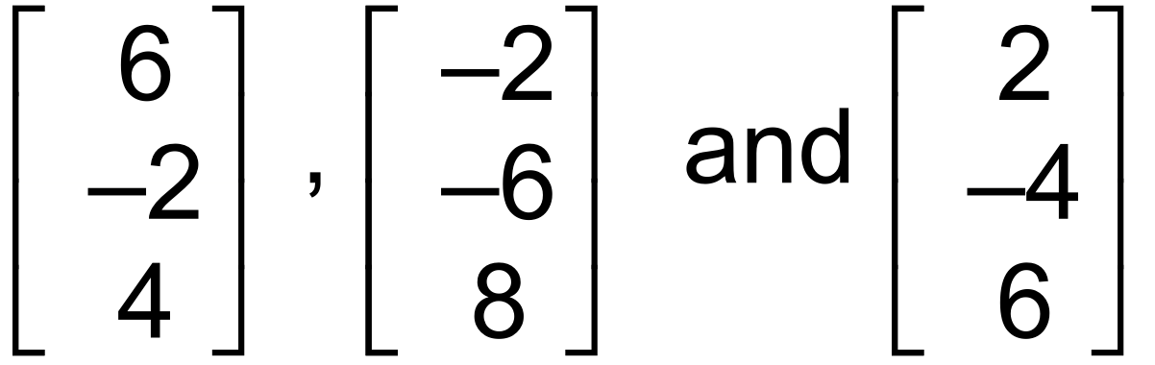.

(a) (i) State which point is the mid−point of the other two. (1 mark)

(ii) State which two points are equidistant from the origin. (1 mark)

(iii) Determine the Cartesian equation of the sphere with centre at the midpoint
found in (a) (i), and radius of 7. (1 mark)

(iv) Show why the point 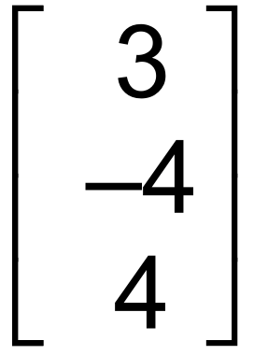 lies inside the sphere found in (a) (iii). (1 mark)

(b) Given O is the origin and  determine a plane, find two vectors that are normal
to this plane. (2 marks)

Question 8 (8 marks)

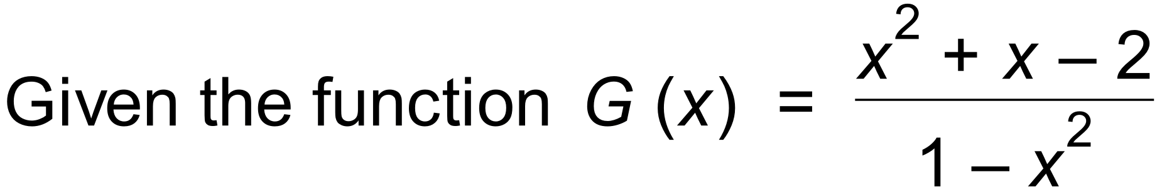 ,

(a) state all asymptotes, intercepts and any other important features of the graph of y = G (x).
(5 marks)

(b) sketch the graph of y = G (x) on the axes below. (3 marks)

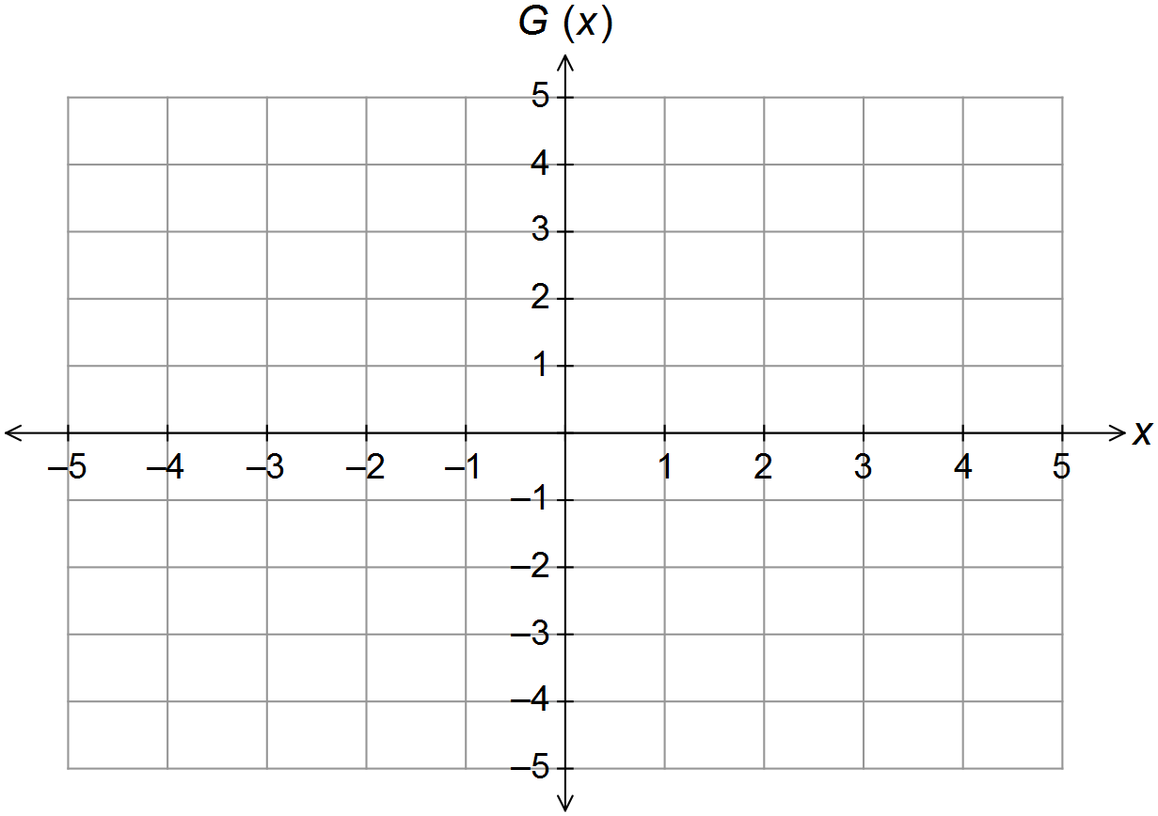

End of Questions
Additional working space

Question number(s): ……………………

Additional working space

Question number(s): ……………………

